**Objectives**

1. Use Packet Tracer and familiarize yourself with the user interface.
2. Drag and drop devices and make connections.
3. Use the GUI configuration screens.
4. Save the file and re-load it.

NOTE: Refer to the file -01b Using Cisco Packet Tracer.PPT and/or take the free NetAcademy course for more help and information.

Reminder: Ensure you have a Cisco Net Academy login to use the downloaded Packet Tracer!

*Important: This assignment is different from the lab we did in class. Read carefully!*

**Part A - Create the topology**

* Launch Packet Tracer on your workstation.
* Select OPTIONS/PREFERENCES/MISCELLANEOUS and ensure BUFFER FILTERED EVENTS ONLY is selected.
* Open a textbox (type N and click, or click the  icon, and enter:
  1. “Assignment 01 – Using Packet Tracer”
  2. Your last name followed by your class id (ex: “Tokash-162”)
* Open another textbox and give an example of a MAC address, an IPv4 address, and an IPv6 address.
* Create the following topology by dragging and dropping the items from the device toolbars. (Remember that the toolbar has device groups on the left, and individual devices on the fight.) Don’t worry about the device names or connectors yet.   
    
  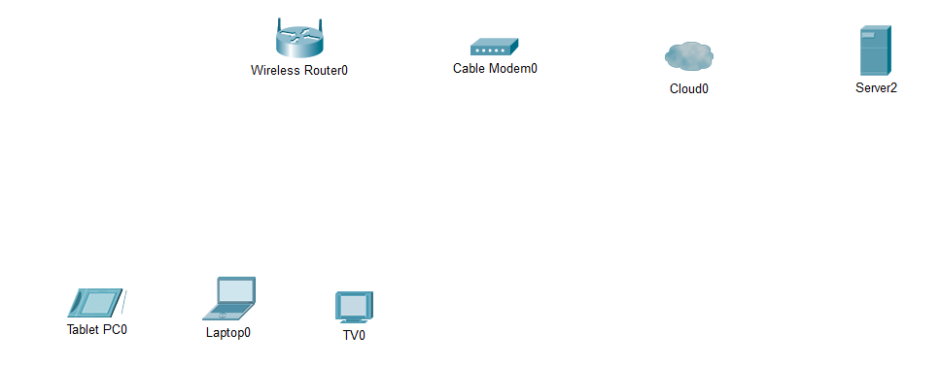  
    
    
  To place a device onto the workspace, first choose a device type from the Device-Type Selection box. Then, click on the desired device model from the Device-Specific Selection box. Finally, click on a location in the workspace to put your device in that location. If you want to cancel your selection, click the Cancel icon for that device. Alternatively, you can click and drag a device from the Device-Specific Selection box onto the workspace.  
    
  Notes: The Wireless Router is the “HOME ROUTER” in the Network Devices/Wireless Devices group. The “CABLE MODEEM” is in the Network Devices/WAN Emulation group. The server is in the End Devices group.
* Change the display names of the network devices to match the topology diagram. Name the tablet and Laptop to your first name (ex: “Andrew’s Laptop”). Click on the device icon on the Packet Tracer Logical workspace, then click on the **Config** tab in the device configuration window. In the Config tab type the new name of the device into the **Display Name** box as show in the figure.  
    
  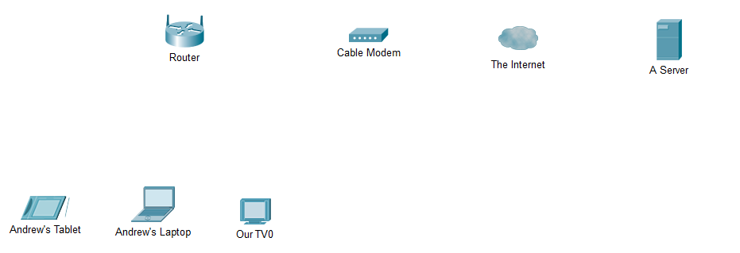
* Using the device selection box, add the physical cabling between devices on the workspace as shown in the topology diagram. *Rather than use the AUTO-SELECT connection, scan over the different connectors to find the correct one.*   
    
  The Wireless Router will need a copper straight-through cable to connect to the Cable Modem. Select the copper straight-through cable in the Device-Selection box and attach it to the Internet interface of the Wireless Router and the Port 1 interface of the Cable Modem.
* The Cable Modem will need a coaxial cable to connect to the Internet cloud. Select the coaxial cable in the Device-Selection box and attach it to the Port 0 interface of the Cable Modem and the coaxial interface of the Internet cloud.  
    
  The Internet cloud will need copper straight-through cable to connect to the Cisco.com server. Select the copper straight-through cable in the Device-Selection box and attach it to the Ethernet interface of the Internet cloud and the FastEthernet0 interface of the server.
* Add a PC to the left of the wireless router. Use copper straight-through cables to connect the PC to the router. Change the display name of the PC to your last name.

**Part B - Configure the Wireless Router**

* Click on the Wireless Router icon on the Packet Tracer Logical workspace to open the device configuration window.
* In the Wireless Router configuration window click on the GUI tab to view configuration options for the Wireless Router.
* Next, click on the Wireless tab in the GUI to view the wireless settings. The only setting that needs to be changed from the defaults is the Network Name (SSID). Here, type the name “HomeNetwork” as shown in the figure. Scroll way down and Click on SAVE SETTINGS. 
* To configure the Internet connection on the Wireless Router click on the Setup tab in the Wireless Router GUI.
* In the DHCP Server settings verify that the Enabled button is selected and configure the static IP address of the DNS server as 208.67.220.220 as shown in the figure.  
    
   
* Scroll way down and click the Save Settings tab.

**Part C - Configure the Laptop**

* Click on the Laptop icon on the Packet Tracer Logical workspace and in the Laptop configuration windows select the Physical tab. *You may have to scroll down to see the bottom of the laptop.*
* In the Physical tab you will need to remove the Ethernet copper module and replace it with the Wireless WPC300N module.

To do this, you first power the Laptop off by clicking the power button on the side of the laptop.   
Then remove the currently installed Ethernet copper module by clicking on the module on the side of the laptop and dragging it to the MODULES pane on the left of the Laptop window. 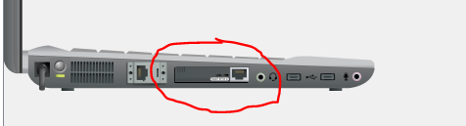  
  
 Then install the Wireless WPC300N module by clicking on it in the MODULES pane and dragging it to the empty module port on the side of the laptop.

Power the laptop back on by clicking on the Laptop power button again.

* With the wireless module installed, the next task is to connect the laptop to the wireless network.
* Click on the Desktop tab at the top of the Laptop configuration window and select the PC Wireless icon.
* Once the Wireless-N Notebook Adapter settings are visible, select the Connect tab. The wireless network “HomeNetwork” should be visible in the list of wireless networks as shown in the figure.



* Select the network, and click on the Connect tab found below the Site Information.
* At this point you should see wireless connectivity to the laptop.

**Part D – Connect the PC**

* Connect the PC to the wireless Router with a straight thru copper cable.

**Part E - Assignment Completion & Supporting Documentation**

* Save the file. Make sure you note the correct folder to place it in. Save it in PKT format.
* For this lab assignment just submit a screenshot of the Packet Tracer screen! Make sure all textboxes you created is included in the screenshot.

Note: Portions of this lab were modified from Cisco's Networking Academy